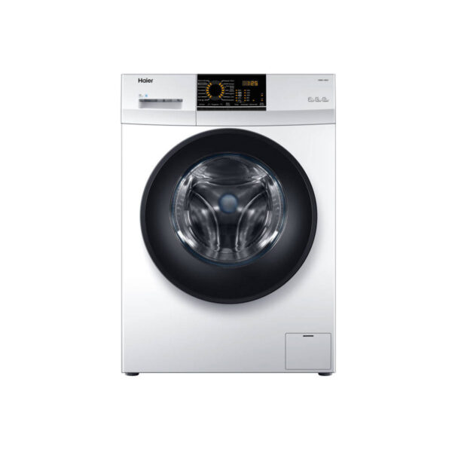

***Haier 4k full auto loaded washing machine double 4k***

* **Color:**White
* **Available:**Out of Stock
* **Motor type:**Induction
* **Program:**10
* **Old Price:**~~Rs 220,000~~
* **New Price:**Rs 134,400